2026 Visiting Team Packet
The Huntsville ISD Athletic Department is excited to host games for the Fall of 2026 season. Below is information for Huntsville ISD Stadium. Please share with any groups that will be accompanying you as well as information you feel is important for your spectators to know. Parking and Bus Map denotes visiting team drop off, band entrance, locker rooms and bus parking

Huntsville High School Tickets
https://huntsvilleisd.hometownticketing.com/embed/all

Scan Code
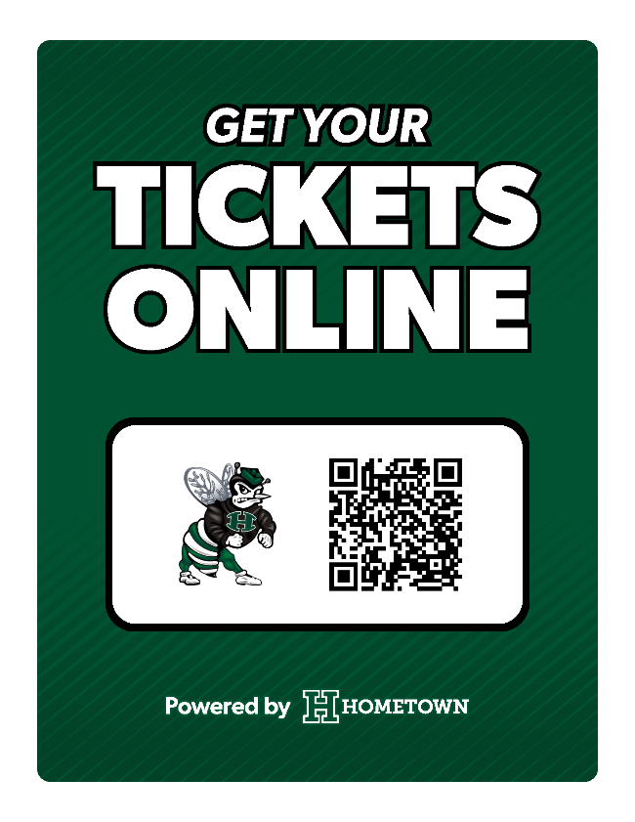

Varsity Games:
Ticket prices: Adult: $10.00 Student: $ 5.00
DIGITAL TICKETS - ONLINE Only

  - Gates will open at 6:00 pm for a 7:00 Kickoff.
  - Only authorized personnel will be allowed on the sidelines or in the end zones. All non-uniformed personnel will be required to display a sideline pass for admittance to the field. *See section 6 of packet
  - No Spectators will be allowed on the field following the game

Sub-Varsity
Digital tickets and tickets at the gate
Ticket prices: Adult: $5 Student: $3:00
*We will have a QR code at the game to assist in purchasing tickets.

Middle School
Digital tickets and tickets at the gate
Ticket prices: Adult: $3 Student: $3

.

Questions, please contact:

Cody Hassell Lisa Blackburn
Assistant Athletic Director Athletic Business Manager
Athletic Offices Athletic Offices
445 FM 2821 East 445 FM 2821 Est
Huntsville, TX 77320 Huntsville, TX 77320
936-435-6135 936-435-6136
cwhassell@huntsville-isd.org lblackburn@huntsville-isd.org

VARSITY FOOTBALL GAME INFORMATION
HUNTSVILLE ISD STADIUM
445 FM 2821 East
Huntsville, TX 77240
936.435.6136

STADIUM FOOTBALL INFORMATION REQUST FROM HEAD FOOTBALL COACH

- Team Roster
- Starting Line Up for Announcer
- Two Deep Offense/ Defense
- Copy of District Pass
- Copy of Sideline Pass

PERMITTED ITEMS

Binoculars
Blankets, coats, jackets
Cameras, video cameras
Cowbells,
Diaper bags, handbags
Handheld Signs
Seat Cushions
Stadium Seats
Umbrellas

NOT PERMITTED ITEMS
Air horns of any kind, train horns, cannons, vuvuzela thunder sticks, laser pointers, fireworks
Balls of any kind, scooters, hoverboards, bicycles, skateboards
Bubbles, baby powder, glitter, or confetti
Containers of any kind, including coolers
Drones and any other unmanned and remote-controlled aircraft systems
Drugs, alcohol, and the use of any tobacco product, including e-cigarettes
Lawn Chairs
Metal cleats on any of the turf playing surfaces
Outside food or beverages. Chewing gum, sunflower seeds are not permitted on any of our playing surfaces and stands.
Pets (except service dogs to aid guests with disability)
Trespassing, soliciting, peddling, and loitering.

HUNTSVILLE ISD FOOTBALL GAME DAY STADIUM GUIDELINES
1. POLICY:
University of Interscholastic League policies, 9-5A or 17-5A policies and Huntsville ISD will be strictly enforced.

2. MEDICAL:
- Medical emergencies at the Huntsville ISD Stadiums varsity football games will be handled by emergency crews from the Huntsville EMS.
- Trainer Information
Field Set-Up and Resources:
● Water Access: Sideline continuous cow at the 50-yard line.
● Injury Supplies: A chest with injury ice and bags.
● Extreme Heat Provisions: Our rapid cooling station is located inside the Athletic Training Clinic connected to the stadium.
● Where to park: Bus parking is located at Huntsville High School’s main campus. Access Hornet Way from FM 2821 Rd E and follow the road to the
designated bus parking area.
● AED: The primary AED is located on the home side. The secondary AED is located in the hallway to the Field House connected to the stadium.
Additional Medical Coverage (Varsity Only):
● Walker County EMS on standby.
● Team Physician/Fellow present on home side.
Medical Time Out (Varsity Only):
● At 6:30 PM on the track near the field entrance to the Field House.
● Attendees:
○ Home and Visiting Athletic Trainer
○ EMS personnel
○ Home and visiting administrator/principal on duty
○ Home and visiting coaching representative
○ Home and visiting sideline official

Emergency Medical Information:
For injuries requiring ambulance transport that are not considered critical or do not require a higher level of care, patients will typically be transported to
Huntsville Memorial Hospital. More serious or critical injuries may require transport to HCA Conroe or Memorial Hermann - The Woodlands, but this decision
remains fluid depending on the severity of the situation. In the event that air medical transport is necessary, the patient may be flown to Texas Medical Center,
although this is unlikely.
If a minor athlete is transported and a parent/guardian is not present, Walker County EMS asks that a school representative remain with them until a
parent/guardian can be present. Please be able to provide athlete demographic information, medications, allergies, etc upon request.
For minor, stable injuries, we coordinate with the coaches to confirm whether a parent/guardian is present and able to transport the athlete. In such cases, we
recommend urgent care clinics, with Texpress Urgent Care being the closest option. Hours of operation are M-F, 8:00 AM–7:00 PM, and Sat/Sun, 10:00 AM–5:00
PM. Therefore, this option will typically only be available during sub-varsity competitions.
● Huntsville Memorial Hospital (Level IV trauma facility) - 110 Memorial Hospital Dr., Huntsville, TX 77340
○ 8 miles away and roughly 15-20 mins by car
● HCA Conroe (Level II trauma facility) - 504 Medical Center Blvd, Conroe, TX 77304
○ 34 miles away and roughly 35-40 mins by car
● Memorial Hermann The Woodlands Medical Center (Level II trauma facility) - 9250 Pinecroft Dr., The Woodlands, TX 77380
○ 41.3 miles away and roughly 40-50 minutes by car
● Texas Medical Center (Level I trauma center) - 6550 Bertner Ave, Houston, TX 77030
○ 76 miles away and roughly 1.5 hours by car

3. LIGHTNING PROCEDURE – Please follow the prompts on the PA and video board:
a. Spectators -
i. Stadium – Exit to your cars
or under bleachers
b. Participants –
i. Band – Proceed to your buses
ii. Athletics – Proceed to the locker rooms
iii Cheerleaders/Dance Squad-Proceed to your buses
iv Home band / dance/ cheer - exit to HHS Gym or Commons area

4. COMMERCIAL PRESS / MEDIA /STUDENT VIDEO/PHOTO
- All Radio, TV and Authorized Commercial Media personnel must use this link for requesting access for Pressbox and Field clearance and access. Those who don’t contact us prior to game day, will not have access. MEDIA CREDENTIAL REQUEST
- Only authorized news media and authorized photographers (student and adult) will be allowed on the field or in the team area before the game, during the game, during half-time and after the game.
Section 1208 of the University Interscholastic League Constitution and Contest Rules the following is stated:
Videotaping/Filming by Individuals. Any individual taping or filming must have permission from the schools involved in the contest and may not obstruct the view of other spectators of the contest.
Commercial Uses. Use of films or tapes for commercial purposes must be approved by all schools involved in the contest.

5. SPIRIT, BAND and DANCE
- All bands, dance teams and cheer teams should park their buses along Hornet Way and enter on the Southeast side of the stadium. *see dotted line on map
- Band and dance team directors and chaperones must wear identifying badges, enter with their groups and sit in the section reserved for them. All bus drivers should also wear identification badges.
- Each school will be allowed a total of fourteen (14) minutes for the half-time performances.
d. Arrangement for half-time refreshments is the responsibility of each group. Empty cans/bottles must be removed by the group responsible.
e. The field is covered with artificial surface. Pointed objects or objects with sharp or uneven edges are prohibited on the field. This includes any props used by a band or drill team. Sidelines are to be kept free of any type of equipment that might injure an athlete as he goes out of bounds.
f. No items of any kind are allowed to be thrown from the field into the stands without prior approval of the athletic department. Please send all requests to Lisa Blackburn via email at lblackburn@huntsville-isd.org by Wednesday at NOON of game week.
g. Live animal mascots are not allowed in the stadium. Dummy mascots, signs, etc., may not be paraded or displayed in the end zones or in front of the opponent's stands.
h. NO band, dance team, cheerleaders or photographer may encroach upon the restraining lines (dotted line) or the bench area (20-yard line to 20-yard line) during the game.
i. Spirit Signs are allowed on the fencing and railing at the stadium. No sign or banner advertising businesses are allowed without the approval of the Athletic Director. Zip ties are required to hang spirit signs (NO DUCT TAPE). All signs and zip ties must be removed at the conclusion of the contest.

6. SIDELINE AND SIDELINE PASSES: Only Authorized Personnel will be allowed on the field or in the fieldhouse area before the game, at half-time, and after the game. Individuals on the field must present their sideline.
- You must obtain a sideline pass or provide a copy of your school’s sideline pass- All personnel on the sidelines who are not uniformed participants must have an approved sideline passes attached to their clothing that will be visible to Huntsville Police and School Administrators on duty.
- If the opponent needs additional sideline passes for Administration, please contact our office lblackburn@huntsville-isd.org
- Teams coming to play at Huntsville ISD Stadium are to provide a copy of their sideline passes to the Athletic Department by Wednesday prior to Varsity Football Game
- Photographers and news outlet personnel are restricted from entering the coach’s box (25 yard line to 25 yard line).
- No one is allowed to stand, photograph, or film from the end zone area of the field without authorization.
- Please be aware of the sideline cameras so as not to block the shot of the cameras.
- Only dance teams, band students, or cheerleaders in uniform, may form spirit lines on the playing field.
- Run-through signs may not be placed on the field if it has been raining and acrylic type paint has been used.
- Glitter is not allowed to be used on any run-through signs, on half-time props or in the stadium seating areas.

7. PRESS BOX: – entry is at the Home side stairs or elevator. Opponent Coach must be on the entry list, please contact Todd Moebes, Athletic director, at wmoebes@huntsville-isd.org.
- Opens at 5:30 for access
- Personnel other than the coaching staff must contact our office for Pressbox access
- We do not have seating for Administration – it is a working pressbox
- Band/Drill Team announcer must be on the elevator list.
- The elevator will be locked 2 minutes prior to the 4th Qtr.

8. PARKING –
a. Visiting football, band, cheer, choir and dance team buses will be parked in the designated areas along Hornet Way. See attached map.
b. Visiting Fans will park in Lot C and Lot D and High School overflow parking
c. Officials will park in Lot B
d. Home team will park in Lot A and Overflow lots at HHS.

9.TICKET GATE: Ticket gates will open at 6:00 pm for a 7:00 Kickoff for Varsity Football and 1 hour for subvarsity events.

10. PASS GATE: Patrons entering Huntsville ISD Stadiums with passes must enter through the Pass Gates only. HISD employees will be admitted by his/her faculty/employee picture badge only at the home gate. Passes accepted: THSCA, TGCA, District UIL (corresponds with HISD District) Senior Citizen Pass (issued from Athletic Office), Minister Pass

Contact Information:

Game Day Administrator: Brian Parker
Athletic Department: Lisa Blackburn, 936.435.6136, Cody Hassell, 936.435.6135
Athletic Director: Todd Moebes, 936.435.6152
Head Athletic Trainer: Mariah Murray, 936.293.6115
Commercial Press/Media Pass Request: LINK FOR REQUEST FORM

